

Open-Source Audit – Python

STUDENT NAME | SOUMOJIT DAS
REGISTRATION NUMBER | 24BOE10034
SLOT | E22
DATE OF SUBMISSION | 31-03-2026

1. Introduction
Open-source software allows anyone to use, edit and share its source code; thus, it is different than proprietary software, which does not support sharing of source code. Open-source software promotes the concepts of transparency and cooperation between programmers; this enables programmers to improve open-source software worldwide.

Open-source software is evident today in the area of technology from the operation systems (Linux) to the programming languages that we use (Python). The use of open-source software has reduced the costs to create or develop an application or program. Using actual code has the same benefit as using open source software, because it creates a barrier for learning.

The primary focus of this project was to learn about open-source using the Python language, which has been used as an example in the development of open-source software, including its history, licensing rights, integration with Linux, and the general ecosystem of open-source software. In addition to programming, this project demonstrates how shell scripts have been developed using open-source software in a Linux environment.

2. The Audit

Part A — Origin and Philosophy

A1. The problem this software was created to solve
Prior to creating python, c/c++ were powerful but cumbersome languages with all-type restrictions and required full comprehension in many methods which made programming much more laborious than necessary.

In 1991, Guido Von Rossum created python with the intent of simplifying programming by providing an easily understood syntax, which includes utilizing spaces for indentation.

Python has been an open source project that allows contributors from around the globe. Because of this fact, python is constantly evolving and being improved upon. Python can be found used extensively in web development, artificial intelligence, data analysis, and automating processes.

The overall reason for establishing python was to simplify the act of programming. The simplicity that python provides has caused it to have become one of the many programming languages utilized today.

A2. The license — what it actually says
The Python Software Foundation (PSF) License is a permissive open-source license under which Python is distributed.

The PSF License grants four freedoms:

1. Use the software
2. Study the software's source code
3. Create derivatives of the software
4. Distribute copies of the software

Although the GPL will force users to distribute modified versions of the software, the PSF License allows businesses to utilize Python without having to disclose any modifications made to the original software.

The GPL requires users to share any modifications; therefore, the PSF License (like the MIT License) is more flexible and encourages broader adoption.

The primary focus of this article is that Python is "free as in freedom", rather than simply "free".

A3. The ethics of open source
Open source refers to the ability to share both software code, as well as technology and knowledge. Is there a question to whether or not all software should be open source? On one side, if all software is open source, then all software would be more transparent to everyone and more people would be able to build on what has already been built to create new things. Additionally, the cost of technology would decrease dramatically and technology would be available to everyone. However, if all software was open-source, it would also make it more difficult for companies to build their own software and make a return on investment (ROI). Some companies will therefore have to use some level of proprietary software to compete and survive in the marketplace. A more philosophical question is whether it is fair for any company to profit from open-source software? I personally find this question somewhat ambiguous; thus, I want to share a few examples that help to illustrate my point. Google and Netflix are two companies that provide services to their customers by using some open-source software including, but limited to, #1, #2, etc. Companies like Google and Netflix derive benefit from other companies that have done similar work to develop open-source software. They also act to improve the quality of open-source software, and in some cases, they will give back to the community once again, improving the quality of the open-source software being developed! The developer who creates software in an open-source licensing agreement has a much more significant relationship with those who will use that source code than the developer would have with a company that uses that source code without giving anything back to the open-source community. By standing on the shoulders of giants (being able to build upon the work that was done by previous developers), developers working with open source can build new products using the results of prior developers’ work rather than creating everything from scratch. In addition, working together and collaborating with other developers allows for increased innovation (as multiple developers are coming up with new ideas) and helps to reduce the amount of time spent developing products that have already been developed by someone else. Finally, because of their contributions to the open-source community, developers should always give credit to the developers who contributed to the projects that they build upon.

Overall, I believe that open-source technology is very beneficial and should exist simultaneously with proprietary software. Open-source software benefits developers by providing them with tools they can use to learn more about software development and to develop new products together with other developers. Proprietary software benefits businesses and contributes to innovation in the world.

In conclusion, I believe open-source software is very important and plays a crucial role in driving innovation, education, and collaboration. Open-source software should exist in conjunction with proprietary software so that there is a proper balance between being an open-source developer and making money.Part B — Linux Footprint
This section shows how Python is structured and managed within a Linux system.

Installation Method
Python is available through the apt package manager in Linux. In my system, Python was already installed by default. It can also be installed using the command sudo apt install python3. This shows that Python is distributed as a package and does not require manual compilation.

Figure1: python3 --version

Key Directories
The Python executable is located at /usr/bin/python3, which I verified using the which python3 command. This shows how Linux organizes software into standard directories. Python, being a programming language, does not maintain a central system-wide configuration file in directories like /etc, nor does it generate logs in /var/log like typical server applications. However, tools built on Python such as pip store configuration files in hidden directories within the user's home folder.

Figure2: which python3

User and Group
Python runs under the current user. The permissions were checked using ls -l /usr/bin/python3, which shows the owner and access rights. This is important for system security. Python runs under the privileges of the current user. This is important for security because if a script is executed with root privileges, it can potentially access or modify critical system files. Running scripts as a normal user helps prevent unintended system-wide damage.

Figure3: ls -l /usr/bin/python3

Service Management
Python is not a system service. It runs only when a script is executed and does not run in the background. Therefore, commands like systemctl are not used. Python is not something that you can manage like a system service on its own. You can manage services that are built using Python. For example, if you are building a web application using something like Flask or Django you can manage these services.
You can start a Python service by using commands like
- systemctl start service-name
- systemctl status service-name
This is how Python works with Linux when you are using it for work. Python works with Linux service management when you are using Python for applications, like these.

Update Model
Python is updated using the apt package manager with commands like sudo apt update and sudo apt upgrade. This ensures updates from the open-source community.

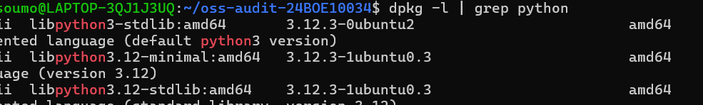
Figure4: dpkg -l

Part C — The FOSS Ecosystem Dependencies
Python needs help from open-source parts to work well. It uses system libraries that come with the operating system. It also needs compilers and runtime environments to function. For instance, it uses C libraries for speed. Tools like pip rely on network libraries and package repositories. This shows that open-source projects like Python are connected and not alone. They depend on each other to work. Python uses these dependencies to work. They help make it strong. The open-source projects are, like a team working together. They show that even Python, a language needs help to function.

Ecosystem and Impact
Because Python has so many useful tools and libraries, it is truly fantastic.
Python is used, for instance, to examine data using NumPy and Pandas. Additionally, they use Flask and Django to create websites. Some even use TensorFlow for machine learning. It is the foundation of all these tools. The primary benefit of Python is its utility. It is more than just a programming language; it's a flexible platform used in a variety of fields, such as web application development, automation, and artificial intelligence. Its widespread application in various fields is a direct consequence of its utility.

Role in Web / LAMP
Python is not usually part of the LAMP stack. The LAMP stack is made up of Linux, Apache, MySQL and PHP. Python does a similar job in modern web development.
Frameworks like Django and Flask help developers build web applications using Python instead of PHP. Python works with databases like MySQL and PostgreSQL. It also runs on Linux servers like the traditional LAMP technologies. This shows how open-source ecosystems change over time. They replace parts with more flexible and scalable alternatives. Python serves this role.

The LAMP stack is no longer the option. It is an alternative. It is used by developers for web development. The use of Python, in web development is increasing. It has become a choice. Python and LAMP stack are used together. Python can also be used alone.

Community and Governance
The Python Software Foundation is the organization that manages the language. It oversees the development of Python and ensures that the project remains opensource for all. Developers around the world contribute to the improvement of the software by posting their ideas on forums, mailing lists, or uploading their codes to GitHub. They also hold conferences where they discuss what the technology should be. When the Foundation decides to make changes, they adhere to a very straightforward procedure. Usually, this happens through Python Enhancement Proposals, or PEPs. Since many people are involved in making these decisions, the language stays useful and is constantly improving. The community really helps keep it relevant by ensuring the tools are aligned with the latest technological trends.

Part D — Open-Source vs Proprietary (Critical Analysis)
A comparison between Python and MATLAB is shown below:
DIMENSION | PYTHON (OPEN SOURCE) | MATLAB (PROPREITARY)
Cost | Free to use and distribute | Paid license required
Security | Source code is open and can be audited by anyone | Source code is closed and cannot be inspected
Support and Reliability | Community support, forums, and documentation | Official customer support provided by company
Freedom to Modify | Can modify and customize freely | Cannot modify core software
Community vs Corporate  Control | Driven by global community (PSF) | Controlled by MathWorks company
Overall Verdict | Flexible and widely accessible | More controlled and specialized

After comparing Python and MATLAB it is clear that both have their advantages. It really depends on what you want to use them for. Python stands out because it is free. It is also very flexible. A lot of people support it. Python can be used for tasks. You can use it for web development. You can also use it for intelligence. On the hand MATLAB is different. It provides a controlled environment. It has dedicated support. This can be useful for engineering and research purposes.
As a student, I find Python more practical and accessible compared to MATLAB. Python is a choice for most applications. This is because it is easy to access. It is also very versatile.
Python allows developers to try things. They can modify things. They can build things without any restrictions .I would definitely recommend Python for use. I might even contribute to it in the future. However, MATLAB still has its place. It is useful in fields. These fields require tools. They also require support from MATLAB. MATLAB is still a choice, for those fields. Python and MATLAB both have their strengths.

3. Shell Scripts
Script 1- System Identity Report Code:
(script1.sh)
#!/bin/bash

# Script 1: System Identity Report
# Author: Soumojit Das
# Course: Open Source Software

# --- Variables ---
STUDENT_NAME="Soumojit Das"

# --- System Info ---
KERNEL=$(uname -r)
DISTRO=$(lsb_release -d | cut -f2)
USER_NAME=$(whoami) HOME_DIR=$HOME
UPTIME=$(uptime -p)
CURRENT_DATE=$(date)

# --- Display --- echo "======================================" echo " Open Source Audit - $STUDENT_NAME" echo "======================================"
echo "Distribution : $DISTRO" echo "Kernel : $KERNEL" echo "User : $USER_NAME" echo "Home Dir : $HOME_DIR" echo "Uptime : $UPTIME" echo "Date/Time : $CURRENT_DATE"
echo "--------------------------------------" echo "This system is typically licensed under" echo "the GNU General Public License (GPL)." echo "--------------------------------------"

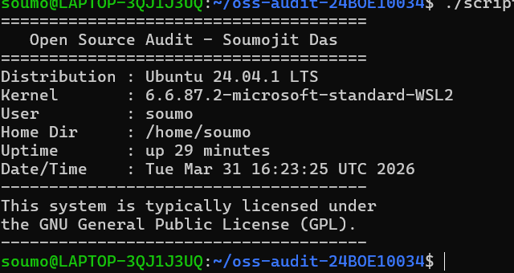
Output- system identity report Explanation:

This script displays basic information about the Linux system in a formatted way. It shows details like the distribution name, kernel version, current user, home directory, uptime, and date/time. It uses variables, command substitution, and echo statements to present the information clearly.

Script 2 — FOSS Package Inspector Code:
#!/bin/bash

# Script 2: FOSS Package Inspector
# Author: Soumojit Das

# Chosen package
PACKAGE="python3"

# Check if package is installed if dpkg -l | grep -q "$PACKAGE"; then echo "$PACKAGE is installed."

# Display package details (version, description) dpkg -l | grep "$PACKAGE"
else echo "$PACKAGE is NOT installed." fi

# Description using case statement case $PACKAGE in python3) echo "Python: A powerful open-source programming language." ;; git) echo "Git: A distributed version control system." ;; vim) echo "Vim: A highly configurable text editor." ;;
*) echo "No description available." ;; esac

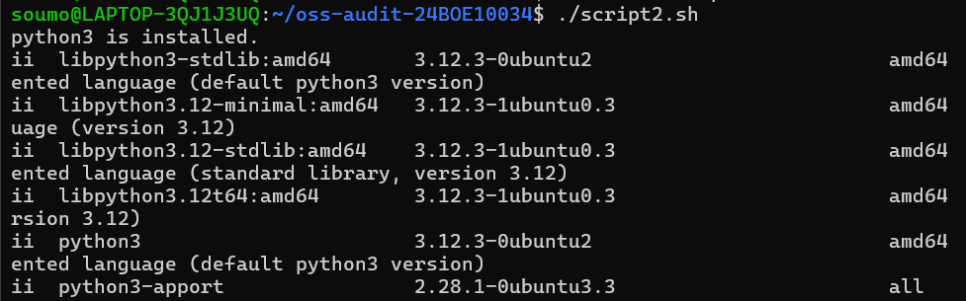

Output- FOSS Package Inspector Explanation:
This script checks whether a specific package (python3) is installed on the system using the dpkg command. If installed, it displays package details, and it also uses a case statement to print a short description of the software. It demonstrates conditional statements and pattern matching.

Script 3 — Disk and Permission Auditor Code:
#!/bin/bash

# Script 3: Disk and Permission Auditor
# Author: Soumojit Das

# List of important directories
DIRS=("/etc" "/var/log" "/home" "/usr/bin" "/tmp")
echo "Directory Audit Report" echo "----------------------"

# Loop through each directory and collect details for DIR in "${DIRS[@]}"; do if [ -d "$DIR" ]; then

# Get permissions, owner, group
PERMS=$(ls -ld "$DIR" | awk '{print $1, $3, $4}')

# Get directory size
SIZE=$(du -sh "$DIR" 2>/dev/null | cut -f1)
echo "$DIR -> Permissions: $PERMS | Size: $SIZE"
else echo "$DIR does not exist on this system" fi done

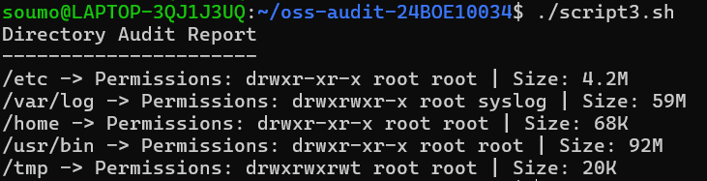
Output- Disk and Permission Auditor Explanation:
This script audits important system directories by looping through them and displaying their permissions, ownership, and disk usage. It uses a for loop along with commands like ls, awk, and du to extract and display the required information.

Script 4- Log File Analyzer Code:
#!/bin/bash

# Script 4: Log File Analyzer
# Author: Soumojit Das
# Usage: ./script4.sh /var/log/syslog

LOGFILE=$1
KEYWORD=${2:-error} # Default keyword is 'error'
COUNT=0

# Check if file exists if [ ! -f "$LOGFILE" ]; then echo "Error: File $LOGFILE not found." exit 1 fi

# Read file line by line while IFS= read -r LINE; do
if echo "$LINE" | grep -iq "$KEYWORD"; then COUNT=$((COUNT + 1)) fi done < "$LOGFILE"

# Output
# Show last 5 matching lines echo "Last 5 matching lines:" grep -i "$KEYWORD" "$LOGFILE" | tail -5
echo "Keyword '$KEYWORD' found $COUNT times in $LOGFILE"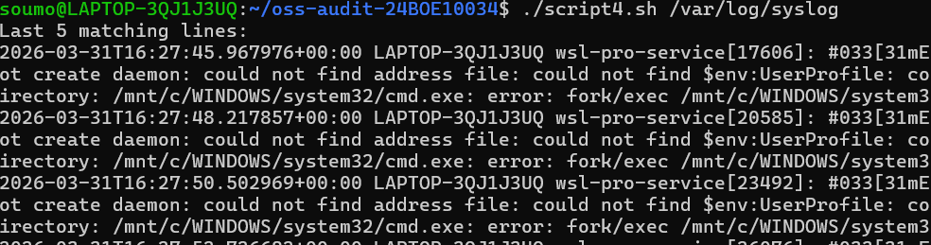

Output- Log File Analyzer Explanation:
This script analyses a system log file by reading it line by line and counting how many times a specific keyword (such as "error") appears. It uses a while loop, conditional statements, and a counter variable. It also accepts command-line arguments, making it flexible to analyse different log files and keywords.

Script 5- The Open Source Manifesto Generator Code:
#!/bin/bash

# Script 5: Open Source Manifesto Generator
# Author: Soumojit Das

echo "Answer three questions to generate your manifesto:" echo ""

# User input read -p "1. Name one open-source tool you use: " TOOL read -p "2. What does freedom mean to you? " FREEDOM read -p "3. What would you like to build? " BUILD
# This script uses user input, string concatenation, and file redirection

# Date and output file
DATE=$(date "+%Y-%m-%d")
OUTPUT="output_$(whoami).txt"

# Create paragraph echo "----- Open Source Manifesto -----" > $OUTPUT echo "On $DATE, I believe that open source tools like $TOOL represent true innovation. Freedom to me means $FREEDOM. Using this freedom, I aspire to build >

# Display output
echo "Manifest saved in $OUTPUT" cat $OUTPUT
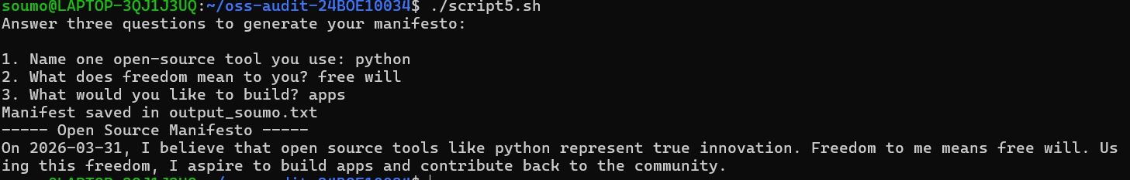
Output- The Open Source Manifesto Generator Explanation:
This script generates a personalized open-source manifesto by taking user input through the terminal. It combines the inputs into a meaningful paragraph using string concatenation and saves it to a text file. It demonstrates user input handling, file writing, and the use of the date command.

4. Conclusion
This project really helped me understand open-source software and how important it is for computing. I learned that Python is an open-source language that's easy to use and can be used by many people. The project also taught me about Linux and how it works inside a computer system. I compared open-source software to software and saw that it is crucial to pick the right tools for the job.

The open-source software project was an experience. It helped me learn more about open-source technologies and scripting at the system level. I got to know open-source software and how it works. Open-source software is very important for computing.

I used Python for this project. It was really helpful. Python is an open-source language. It is very accessible. The Linux analysis was also very useful. It showed me how software works in a system.

The project was a success. I learned a lot from it. I learned about open-source software and its importance. I also learned about the difference, between source and proprietary software. Open-source software is the way to go for people.

